**OS LAB 1 (Home Tasks)**

**Laiba Fatima**

**22k-5195**

Q1: Open a terminal and print the following output on the terminal (Note use single echo

command)

“Welcome to Linux

Linux is free, secure and open source”

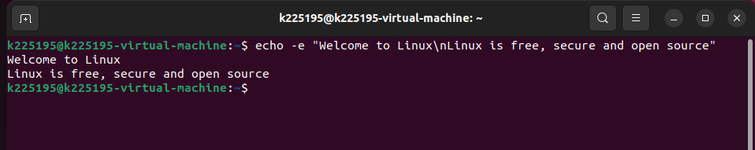

Q2: Perform the following

a. Make a Folder name it oslab on Desktop

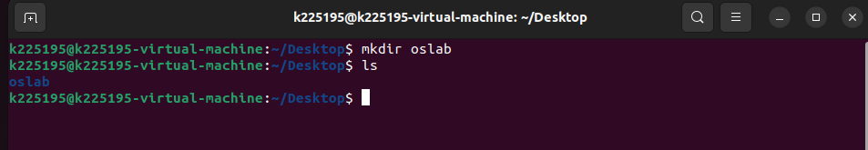

b. Add two text files inside file1.txt and file2.txt

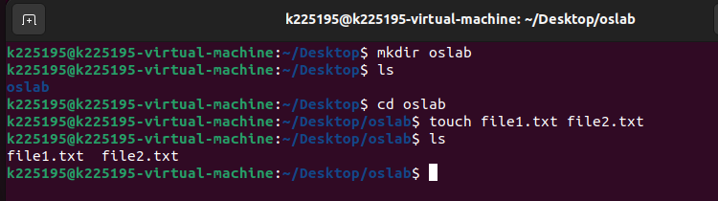

c. Make a third file as file3.txt and file3.txt should merge the content of file1.txt and

file2.txt

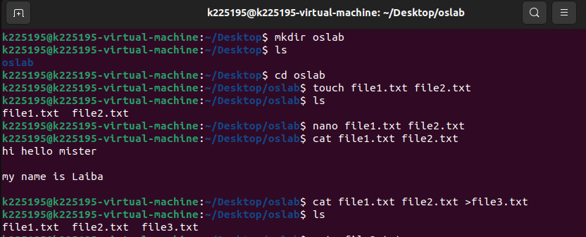

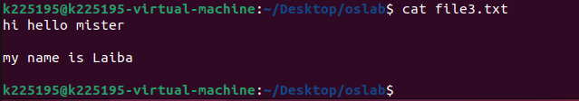

Q3: Rename the above folder oslab to to lab1

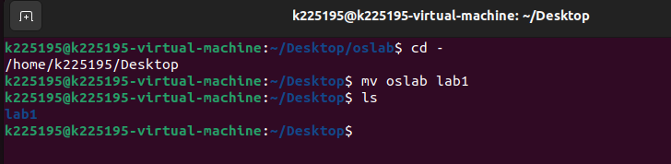

Q4: List out the previous 40 command being run previously on terminal and then clear the

history. after clearing the history check the history again

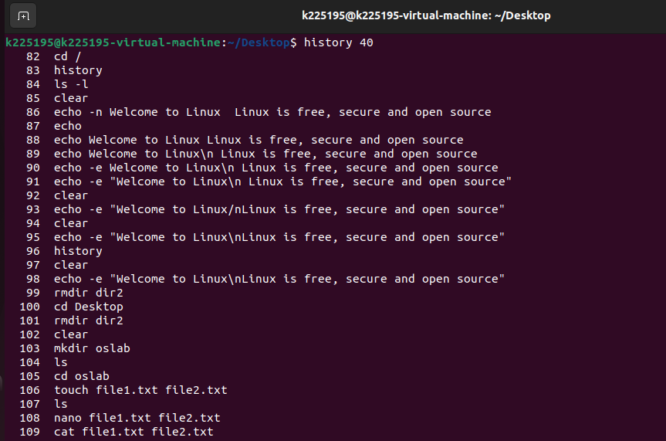

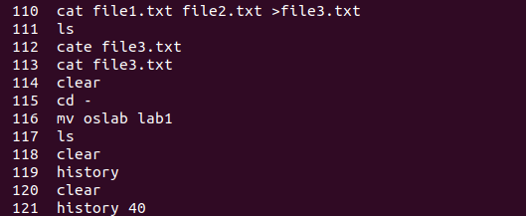

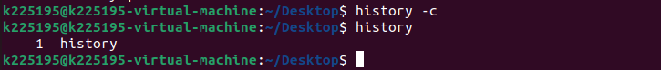

Q5: Do the following

a. Add the new user with name testuser and set the password as test1234.

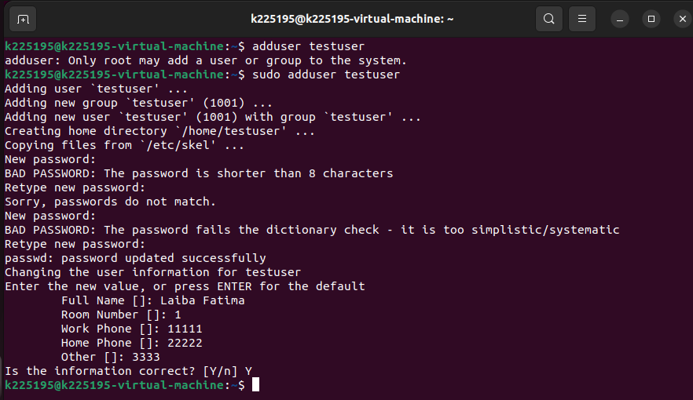

b. Now list the users’ folders on the terminal using ls command.



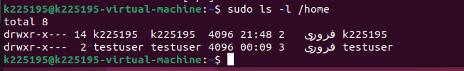

c. Change the password of testuser to change1122

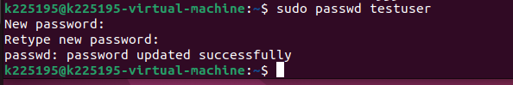

d. Login using testuser





e. Restart the system using terminal and then then delete the testuser

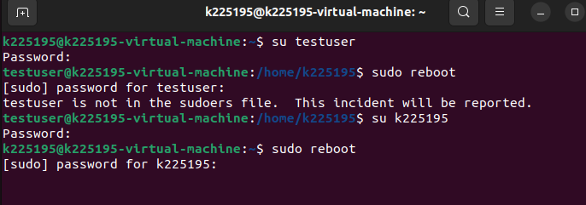

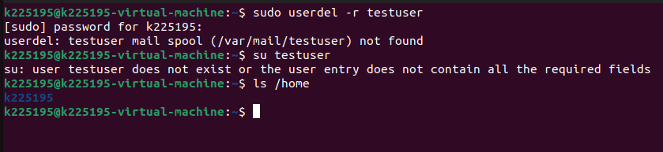

Q6: Do the following

a. Use find command to search for files that have “.txt” file extension

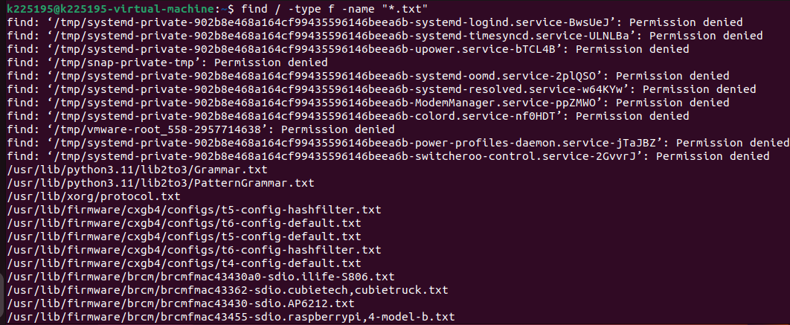

b. Make an alias for exit



c. List all aliases

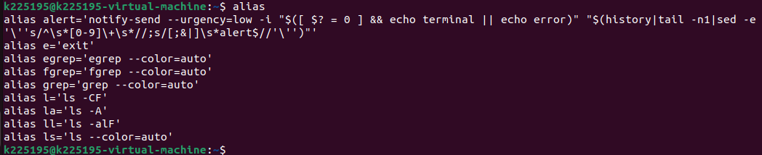

d. Remove the alias you created before for exit

